CSA1423 – Compiler Design

NAME : JOSHNA S P

REG NO : 192421403

SUBJECT: CSA1423 COMPILER DESIGN

EXPERIMENT 6 AND 7

# Experiment 6 – Extend the Lexical Analyzer to Check Comments

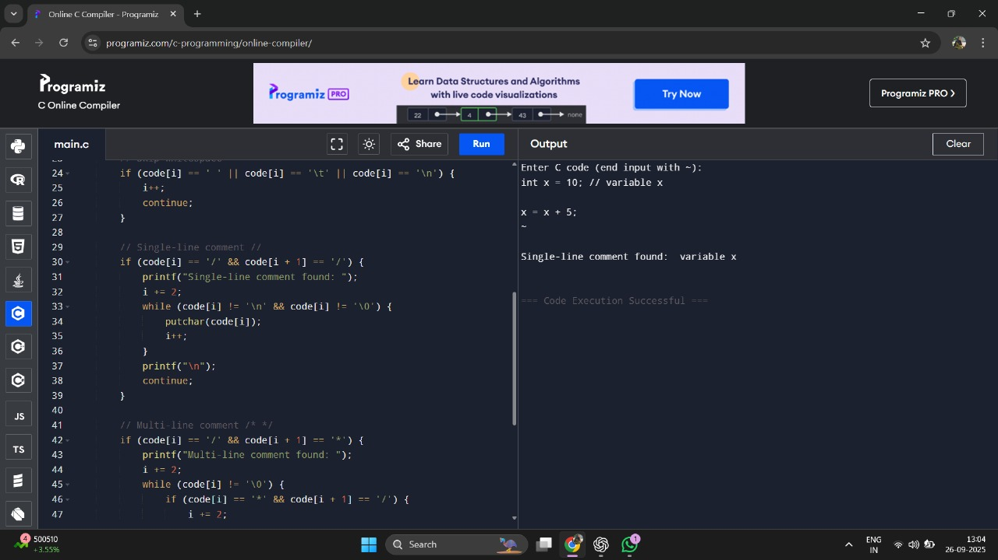

# Experiment 7 – Lexical Analyzer for Identifiers, Constants, Operators

